Bug Report: #402 – Checkout Crash with Promo Codes
Summary: Checkout page crashes with a 500 error when submitting payment using a valid promo code.

1. Environment
- Device/Platform: Windows 11, Desktop
2. Severity & Priority
- Severity: Critical (The search has an error)
- Priority: High (Direct impact on revenue)
3. Steps to Reproduce
- Enter the menu of the app.
- Type “1” to go to the search option.
- Type in the name of the book you want
- See the details off the book you searched for.
- Go back to the menu.
4. Expected Result
The user should be able to type the name of the book and get the details for that said book
5. Actual Result
The book does not show up and it just says that there is no book with that title
- Screenshots/Recording
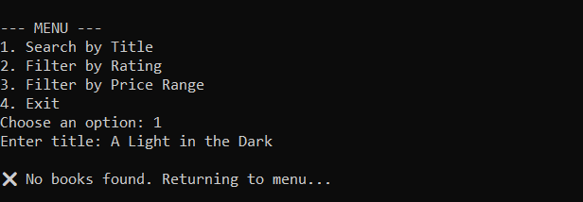
7. Additional Context
- This issue could make people not want to use out app and cause an outrage.

